M Recharge System
M Recharge System basically used for Recharge your mobile phone through website. This Application Contain mainly 4 modules first Module Contain Admin Module All the Access come Under in Admin Module. In Second Module Contain For Distributer Crated by Main Admin .After that Distributer also Create Dealer. And Dealer Also Create User. User Also Used this System and Staff Member will be also to See All Transaction of Amin,Distributor,Dealer and User There.
ADMIN MODULE:
- Admin Dashboard: This is Admin Dashboard in that What Ever Right For Admin you can Blow Screen Short.

2)Distributer: In this Admin Can see The Information of Distributer like UserName,Password,Category, Balance Address etc..Admin Can Also Add This Information and Delete This Information.
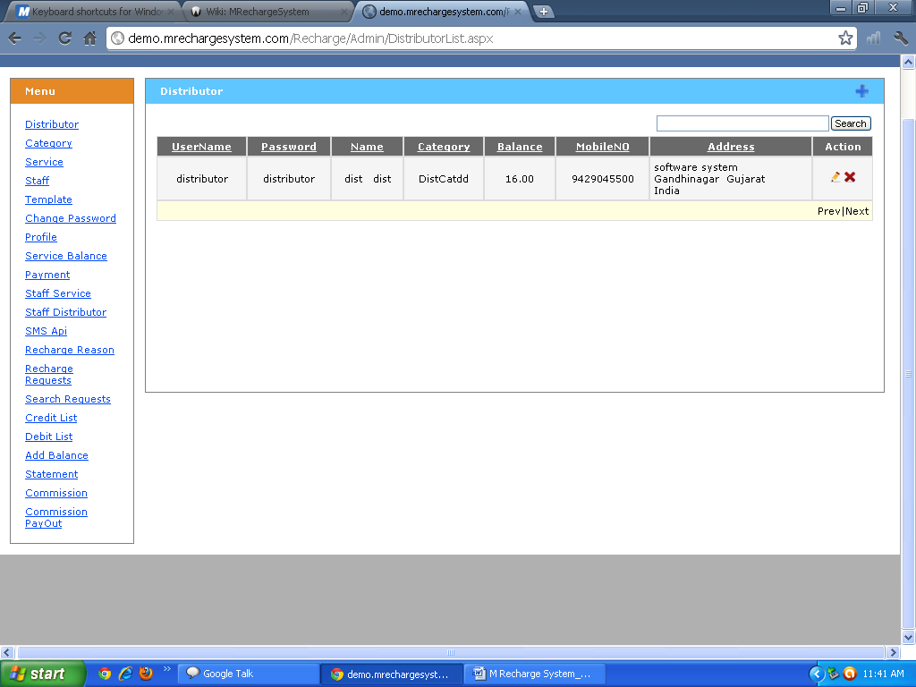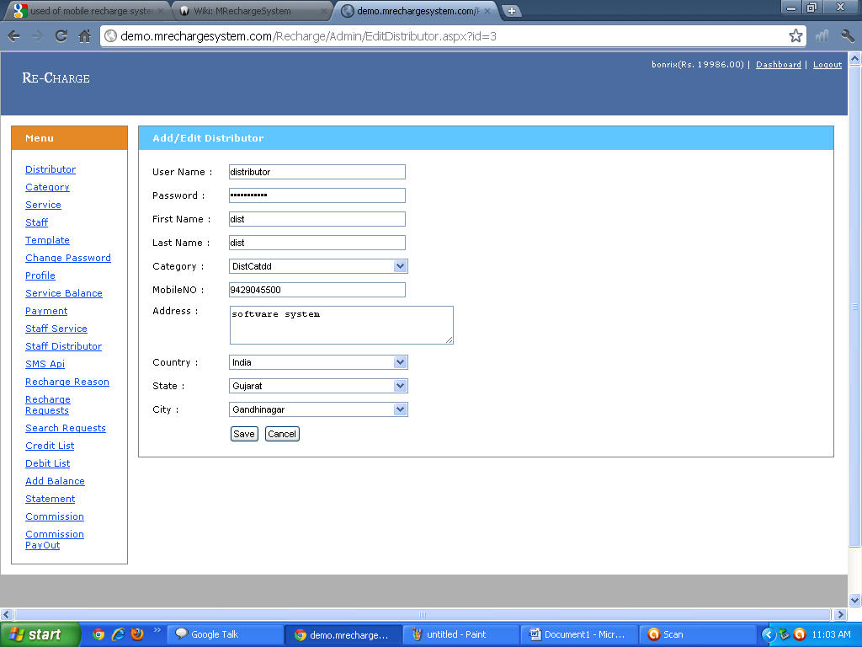

3)Category:Admin can see how many type of Distributer is their in his System.And Admin Can Also Add This Infromation And Admin Can Also Delete This Category.
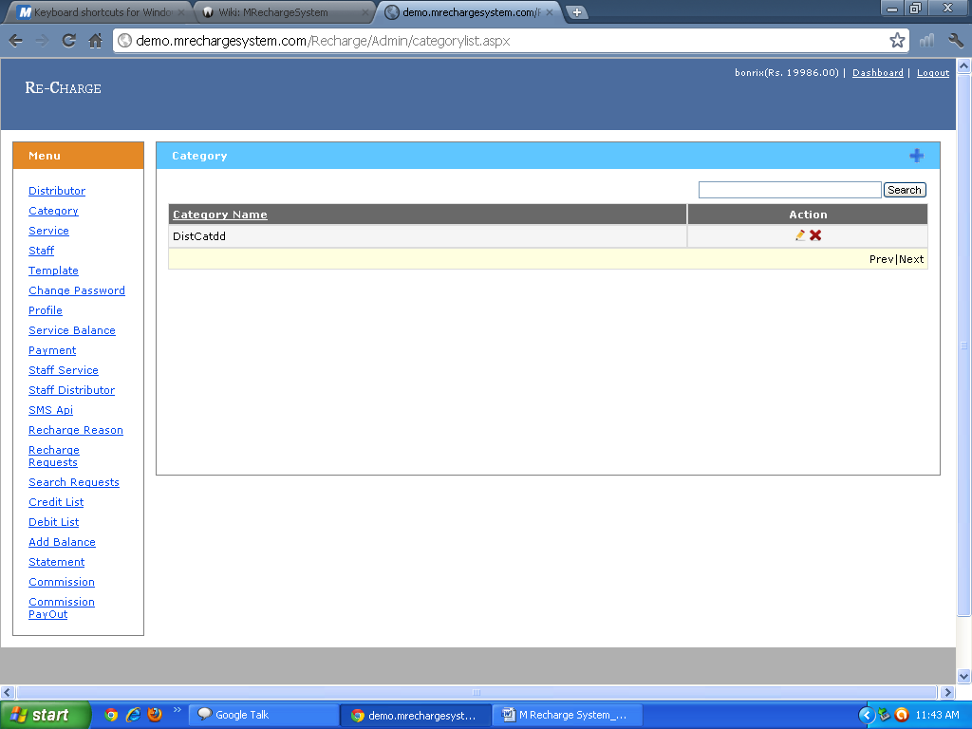4)Services: Admin can See How Many Type of Services he can provided to Distributer. Admin can Also Edit This Information And He Can Also Delete This Services
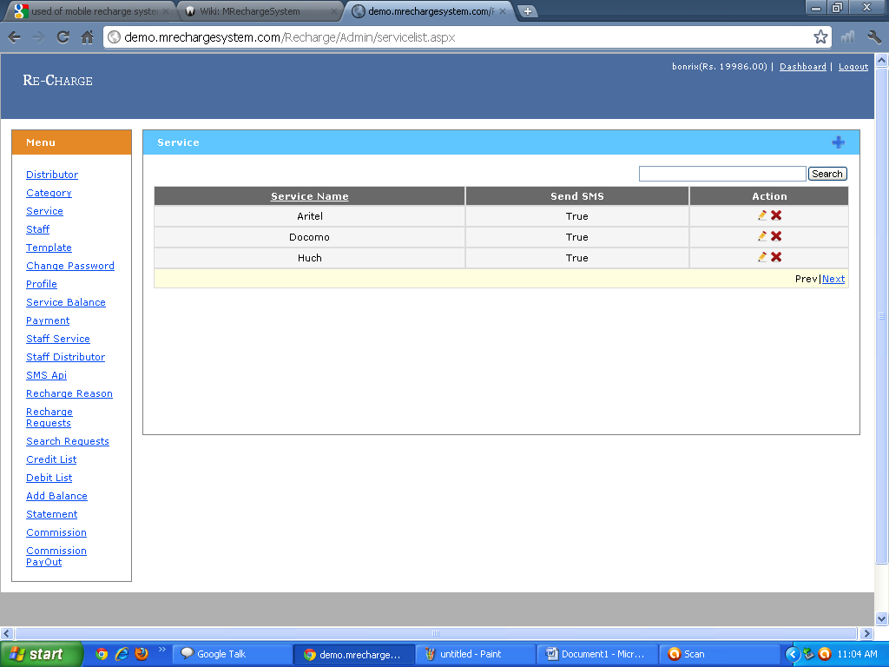

5)Staff:Admin can See All Information Regarding Staff and He can Also Delete Perticular Infromation .You Can see Blow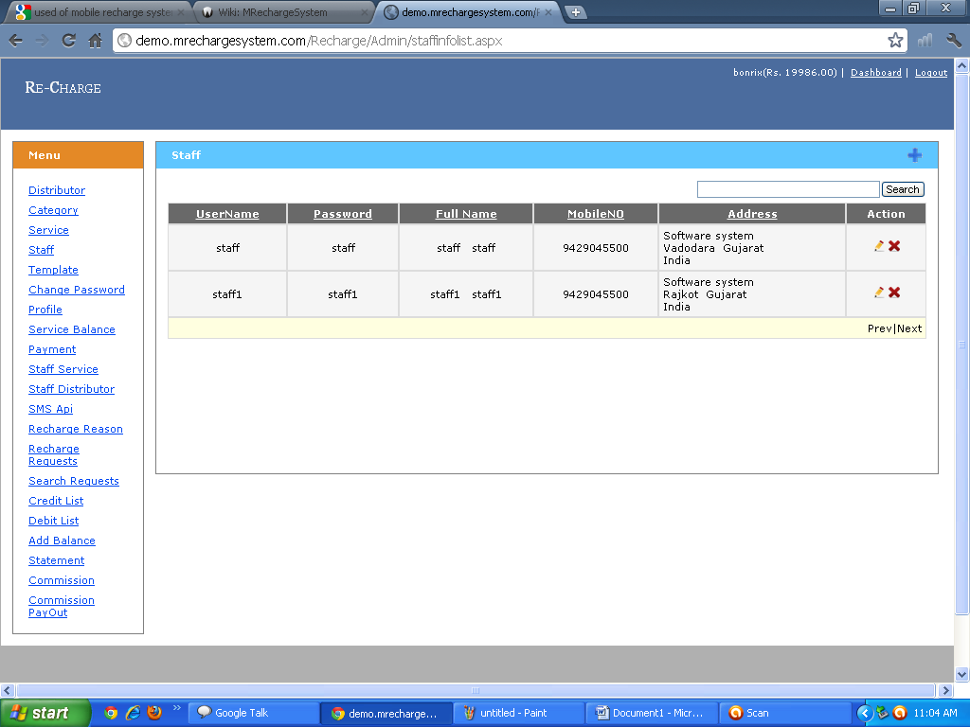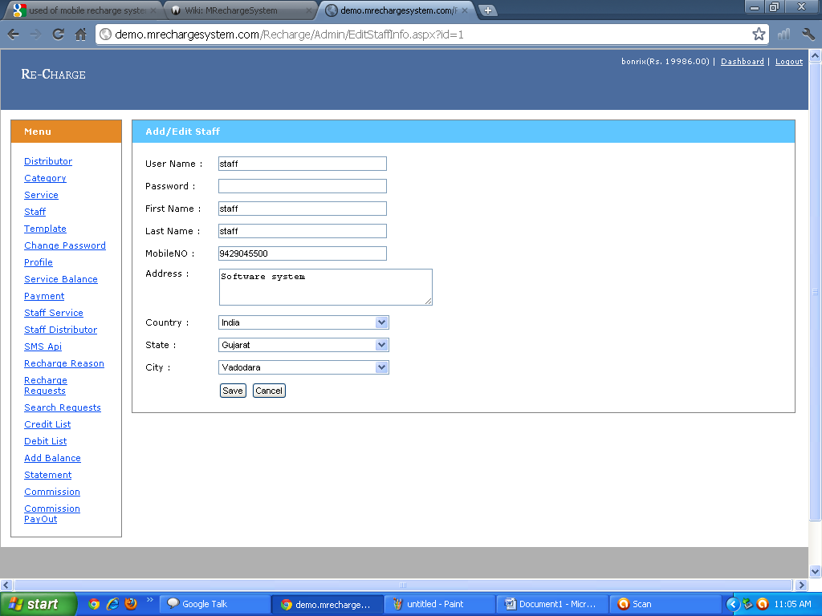

6)Template:After Recharge This Different Type of Message Recived in yor Mobile Phone.And Admin can Also Add Delete or Edit This Template 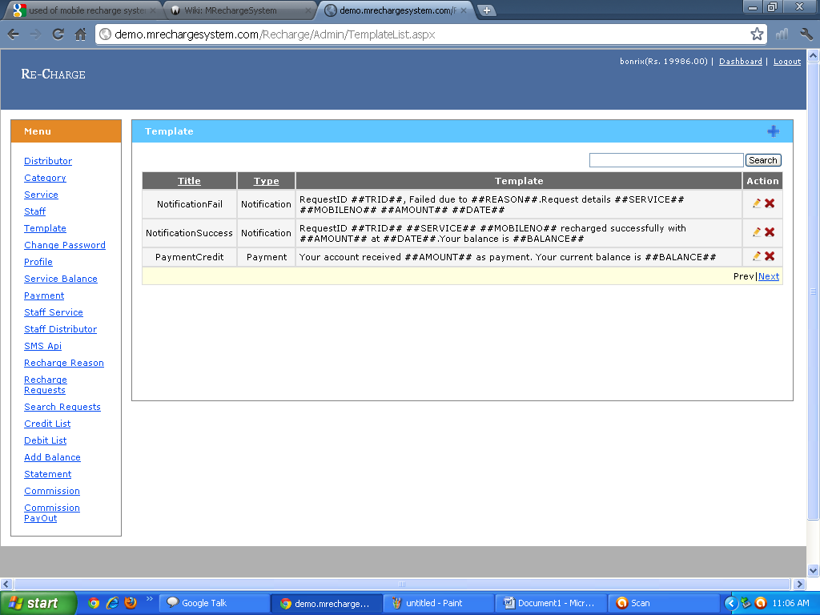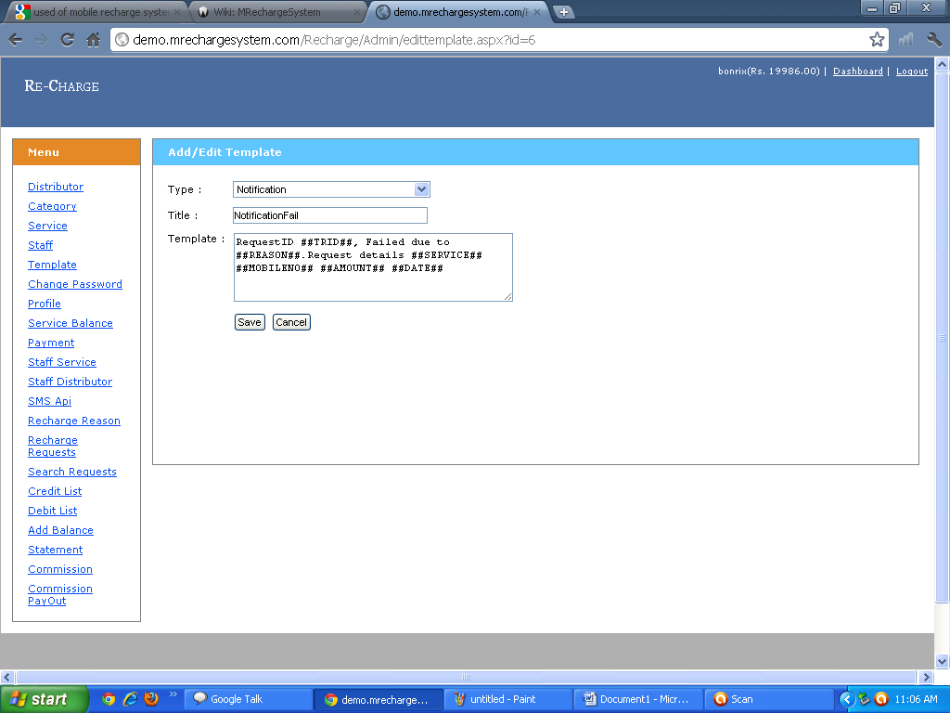
7)Change Password:Admin Can Also change his Password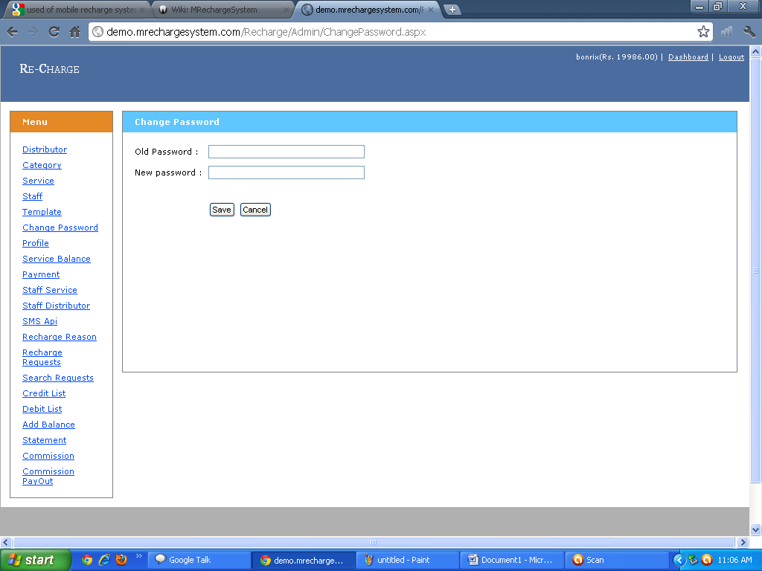9)AdminProfile:Admin can see his Profile Information and he canalso Edit his Information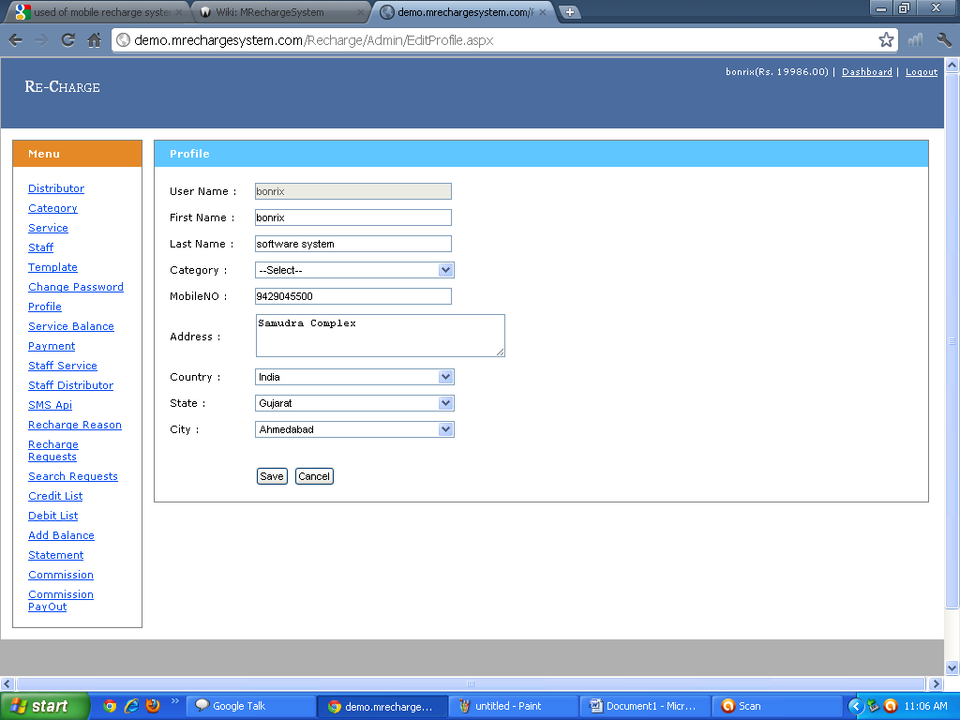

10)Service Balance:Admin can see All Details ofservice Balance Module and Admin can search Particlure Information. 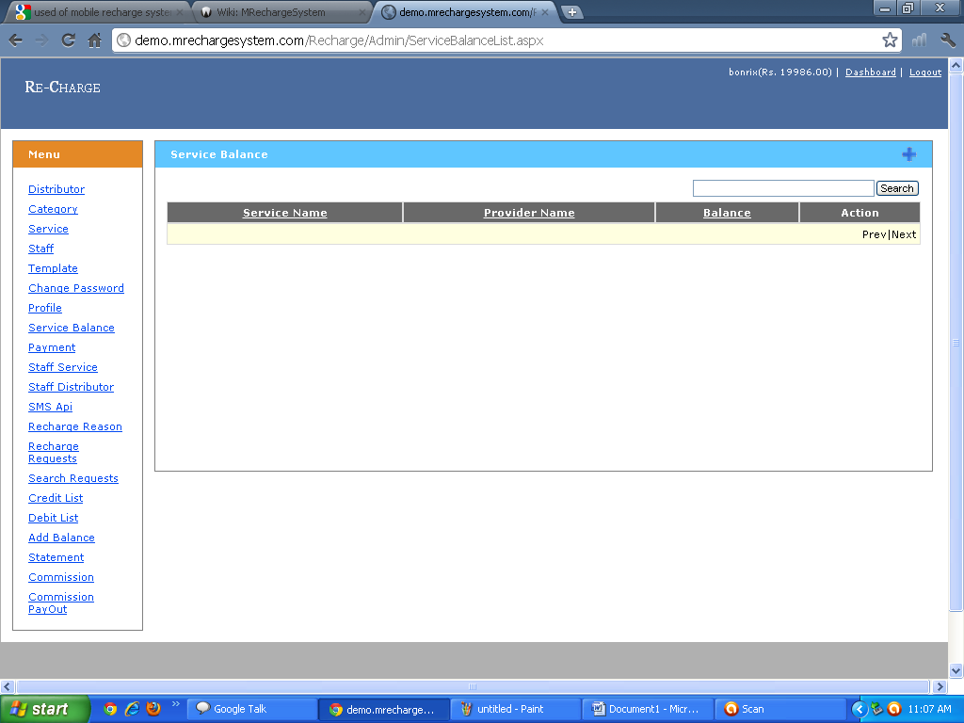11)Payment Module:Admin can fill the Information Regrading Distributor Payment After that Admin can Show the Payment Information 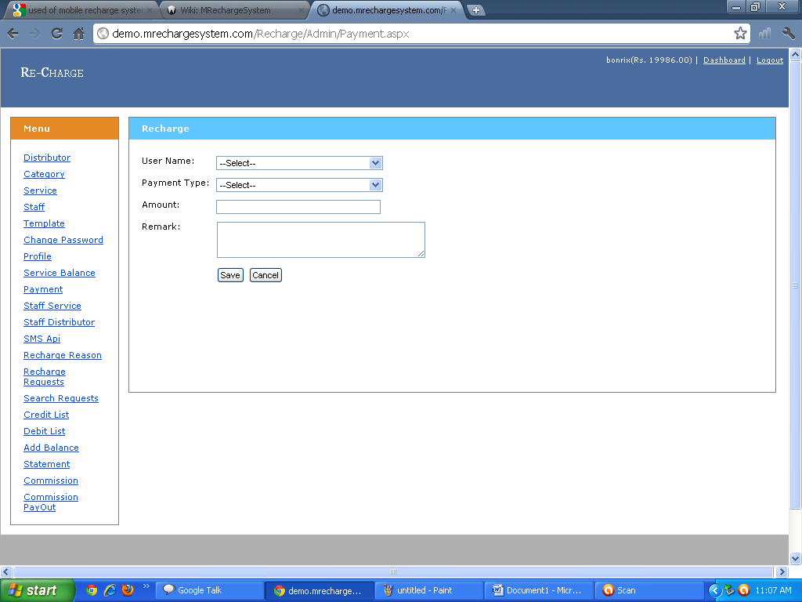
12)Staff Services:Admin can Add Delete and Edit the Staff Information 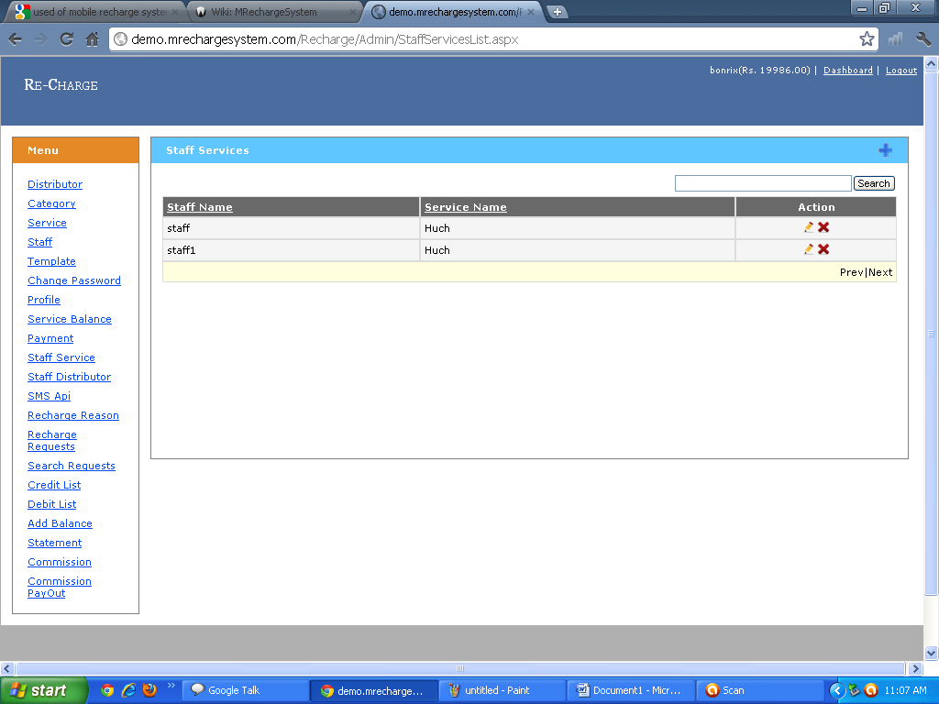13)Staff Distributor:Admin Can Add Delete and Edit Information Regrading Staff Distribution.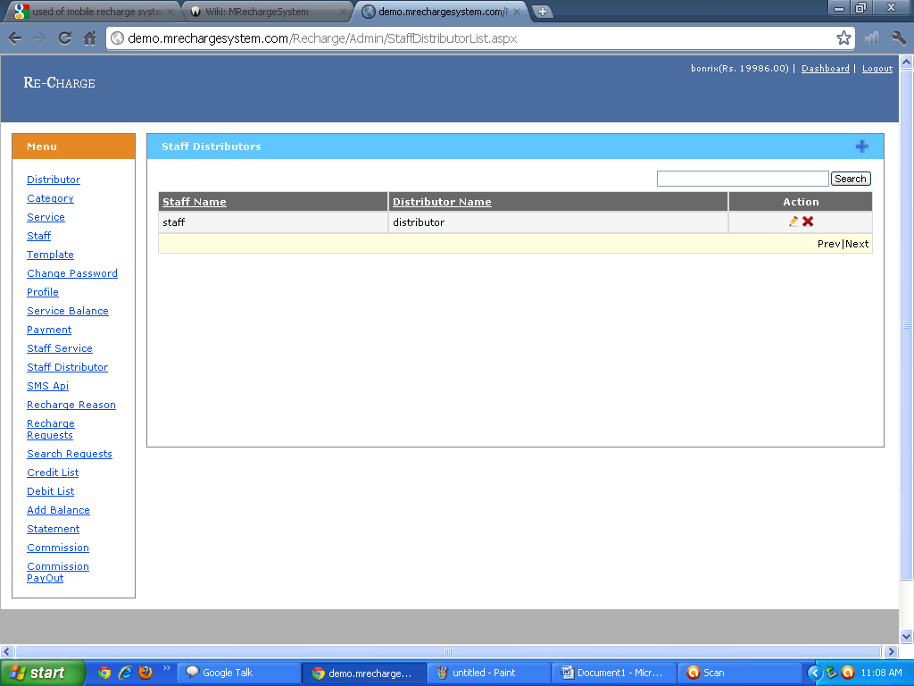

14)SMS API:Admin can used API For Send the SMS and What Type Respone Given Back Through Sms 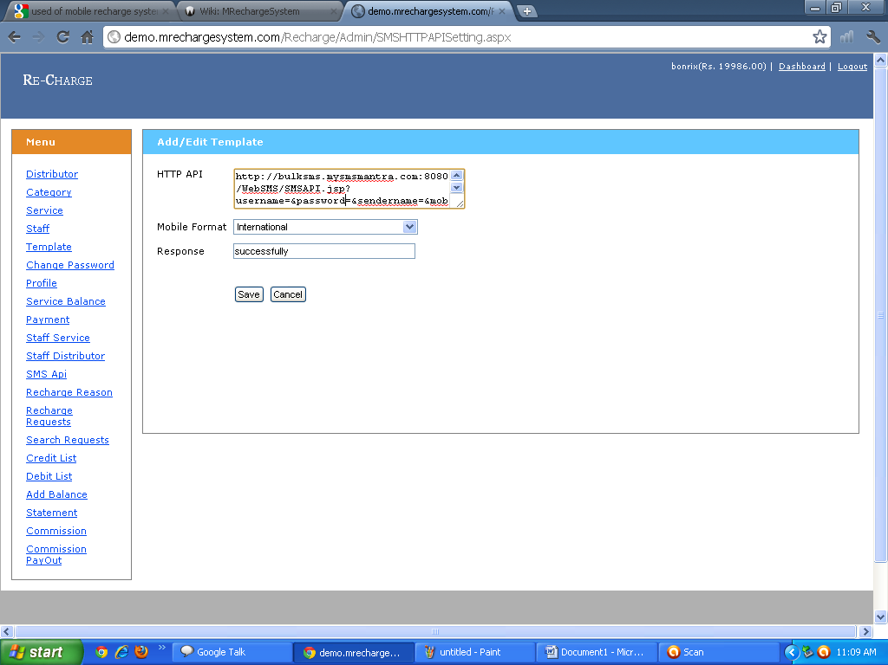15)Recharge Reason:Adim can Add Reason Delete Reason and also Edit the Service Reply Through SMS.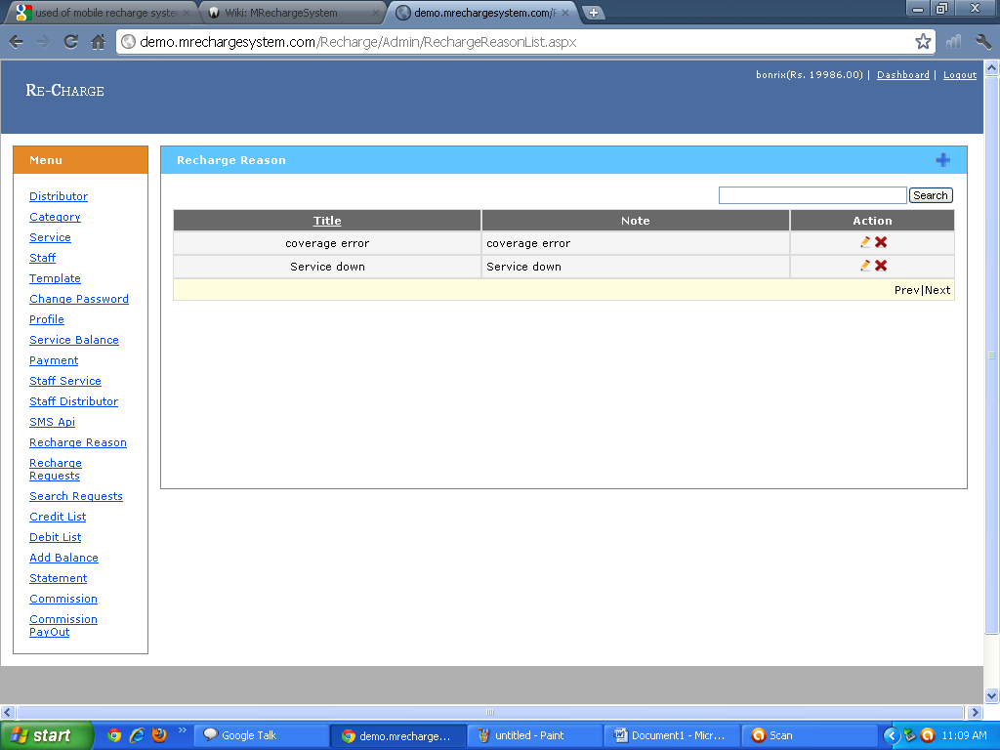

16)Reacharge Request:Admin can see The Information Regarding Recharge Request of Distributor,Dealer,User and Staff .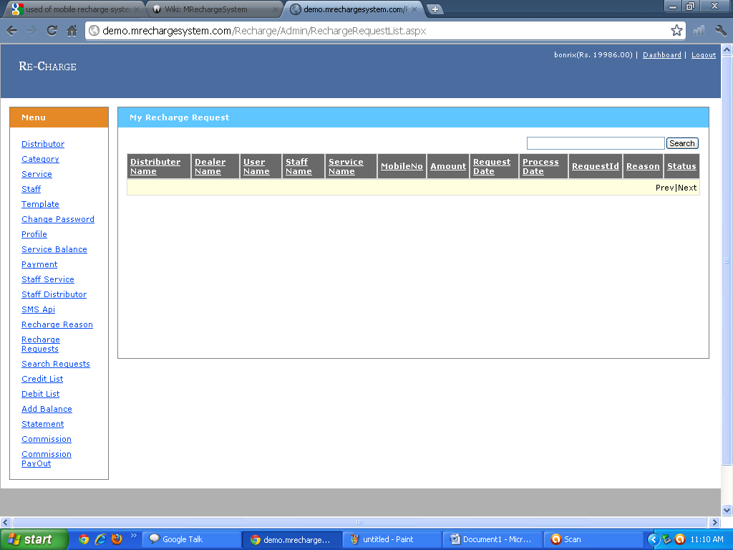17)Credit List:Admin can see the Credit List and see the Transaction Details and Status and used AdvanceSearch option for Finding particular infromation. 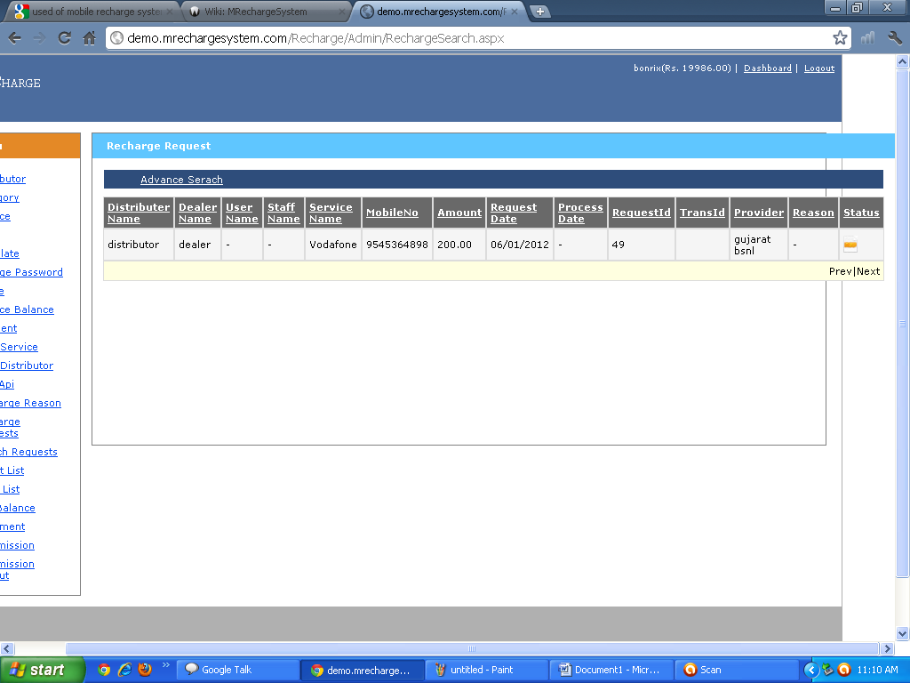
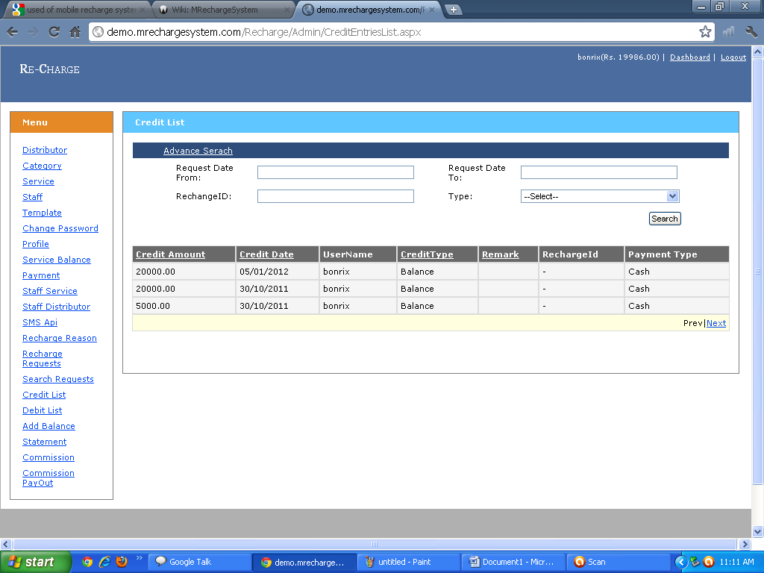18)Debit List: Admin can see the Debit List and see the Transaction Details and Admin can also used Advance Serch for finding particular user . 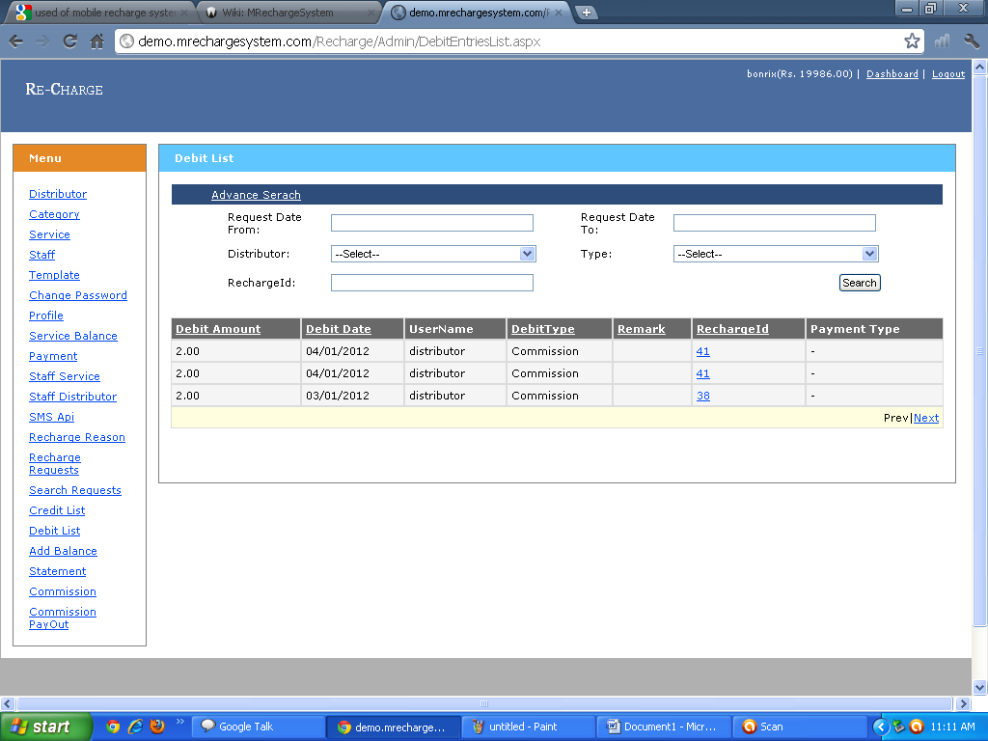19)Add Balance:Admin Can also Add Balance From Here.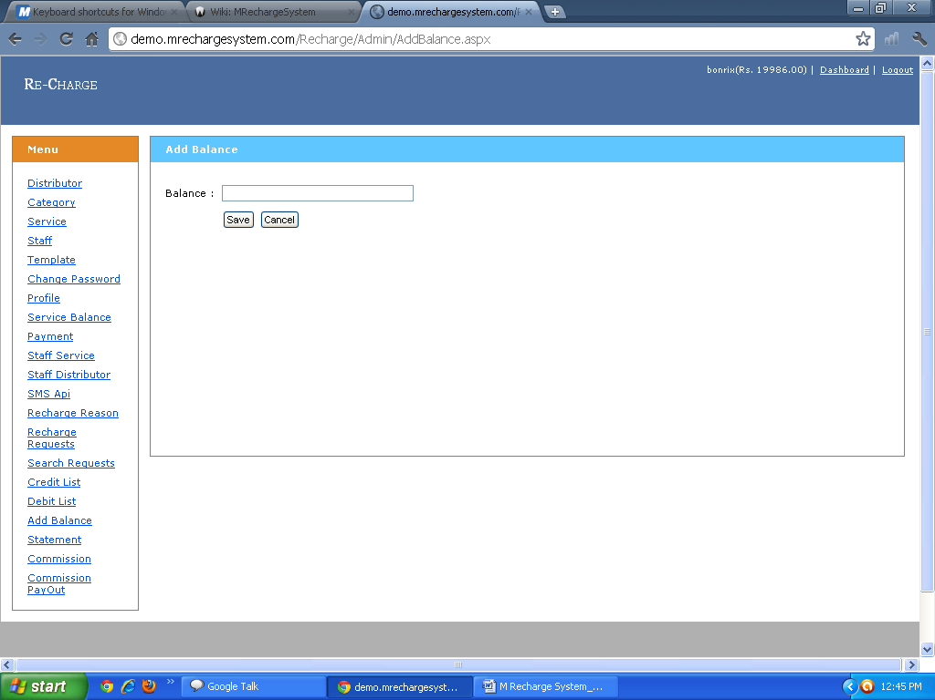

20)Commission:Admin can decide How much will be apply the particular Services and Admin can Also Update This Commision.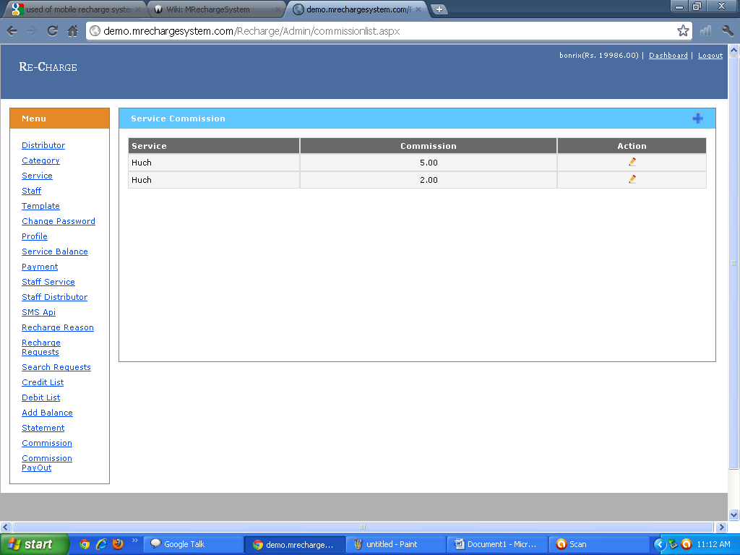21)Commission Payment:Admin can see That Howmany Payment He Get Through Particular Services and also find the total Amount Of Service and Admin can also Advance search for finding Commission for Particular Service. 